The People’s Assembly, convening on the 1st of August 2023 under the 35th PA Meeting.

The Assembly, recognising the current situation,

Constitutes the need to recognise the Ursula Republic with the following information:
Name: Ursula Republic
Founding Date: 29/07/2023
Recognition Date: 01/08/2023
Colours: Blue – Yellow – Red
Primary Colour: Blue
Denonym: Ursulan
Territory: [APPENDIX A]
Flag: [APPENDIX B]
3 Letter Abbreviation: ULR

And proceeds.

Signed by,
DrPiriquito
FVerndari
Comradedoggo_23
Thanster
Lunar_Lunatic_

[Motion 35-2: To recognise the Ursula Republic]

APPENDIX A:
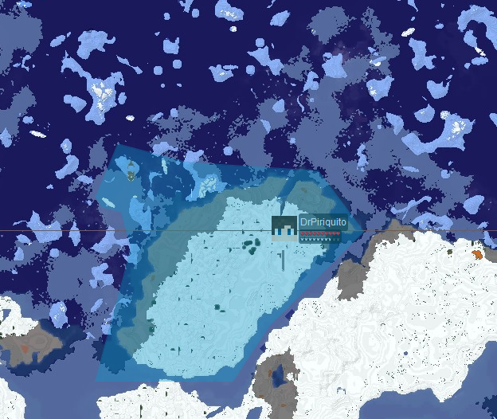
APPENDIX B:


